 | 12.1.10 Editors - Geometry Nodes Editor - Header - Add Menu - Input
Table of content
Detailed table of content 1
Add menu - Input 2
Collection Info 2
Is Viewport 3
Material 3
Object Info 3
Random Float 4
String 4
Value 5
Vector 5

Detailed table of content
Detailed table of content
Detailed table of content 1
Add menu - Input 2
Collection Info 2
Inputs 2
Collection 2
Properties 2
Transform Space 2
Original 2
Relative 2
Outputs 3
Geometry 3
Is Viewport 3
Outputs 3
Is Viewport 3
Material 3
Outputs 3
Material 3
Object Info 3
Inputs 3
Object 3
Outputs 3
Location 3
Rotation 4
Scale 4
Geometry 4
Random Float 4
Inputs 4
Min 4
Max 4
Seed 4
Outputs 4
Value 4
String 4
Properties 4
String 4
Outputs 4
Value 4
Value 5
Properties 5
Value 5
Outputs 5
Value 5
Vector 5
X Y Z 5
Output 5
Vector 5

Add menu - Input
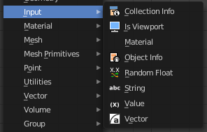
Here you find input nodes.

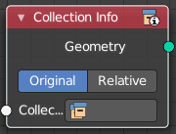
Collection Info
The Collection Info node retreives information from collections. This can be useful to use an external collection to control parameters in the geometry node tree.

Inputs

Collection
Collection to get the properties from.

Properties

Transform Space
The transformation of the geometry outputs.

Original
Output the geometry relative to the collection offset.

Relative
Bring the input collection geometry into the modified object, maintaining the relative position between the objects in the scene.

Outputs

Geometry
Geometry of the collection in world space with all its modifiers applied.

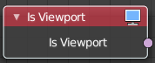
Is Viewport
The Is Viewport node outputs true when geometry nodes is evaluated for the viewport. For the final render the node outputs false.

Outputs

Is Viewport
A booleran that indicates if the geometry nodes is evaluated for preview.

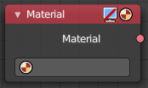
Material
Retreive a material.

Outputs

Material
The material output.

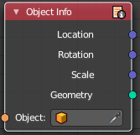
Object Info
The Object Info node retreives information from objects. And outputs it then.

Inputs

Object
Object to get the properties from.

Outputs

Location
Location of the object in world space.

Rotation
Rotation of the object in world space.

Scale
Scale of the object in world space.

Geometry
Geometry of the object in world space with all its modifiers applied.

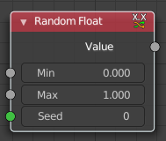
Random Float
The Random Float generates a random (floating point) value from a given range.

Inputs

Min
Minimum random value.

Max
Maximum random value.

Seed
The random seed.

Outputs

Value
The random generated value.

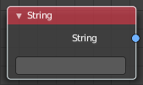
String
Input a string.

Properties

String
The string that you want to input.

Outputs

Value
The value set in the node properties.

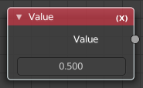
Value
Input numerical values to other nodes in the tree.

Properties

Value
Single numerical value (floating point).

Outputs

Value
The value set in the node properties.

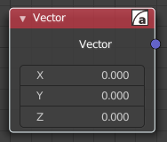
Vector
Creates a single vector of three values that can be used as an input.
Properties

X Y Z
The values of the vector.

Output

Vector
Standard vector output.

